Model Development Phase Template

Date | 06 November 2024
Team ID | 739763
Project Title | Age and Gender Detection Using Deep Learning
Maximum Marks | 4 Marks

Initial Model Training Code, Model Validation and Evaluation Report
The initial model training code will be showcased in the future through a screenshot. The model validation and evaluation report will include classification reports, accuracy, and confusion
matrices for multiple models, presented through respective screenshots.

Initial Model Training Code:

Model Validation and Evaluation Report:

Model | Classification Report | Accuracy
Logistic  Regression | 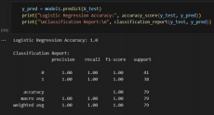 | 1.0

Artificial neural  networks | 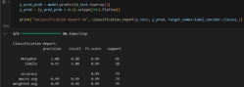 | 0.9

